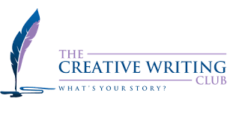

Creative Writing Club

All students are welcome to join!

Lead contact: Allie RIGBY, U.S. Fulbright English Teaching Assistant (ETA) 2022-2023

Home University: San Francisco State University, CA

Meets every other Friday, beginning October 14 from 10:00 -11:30, at the American Corner, Campus A, second floor

Dates: 14 October, 28 October, 11 November, 25 November, 9 December, 23 December