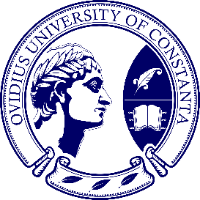

CONFERENCE PROGRAM

INTERNATIONAL CONFERENCE
“(Inter)cultural Dialogues”
5th edition

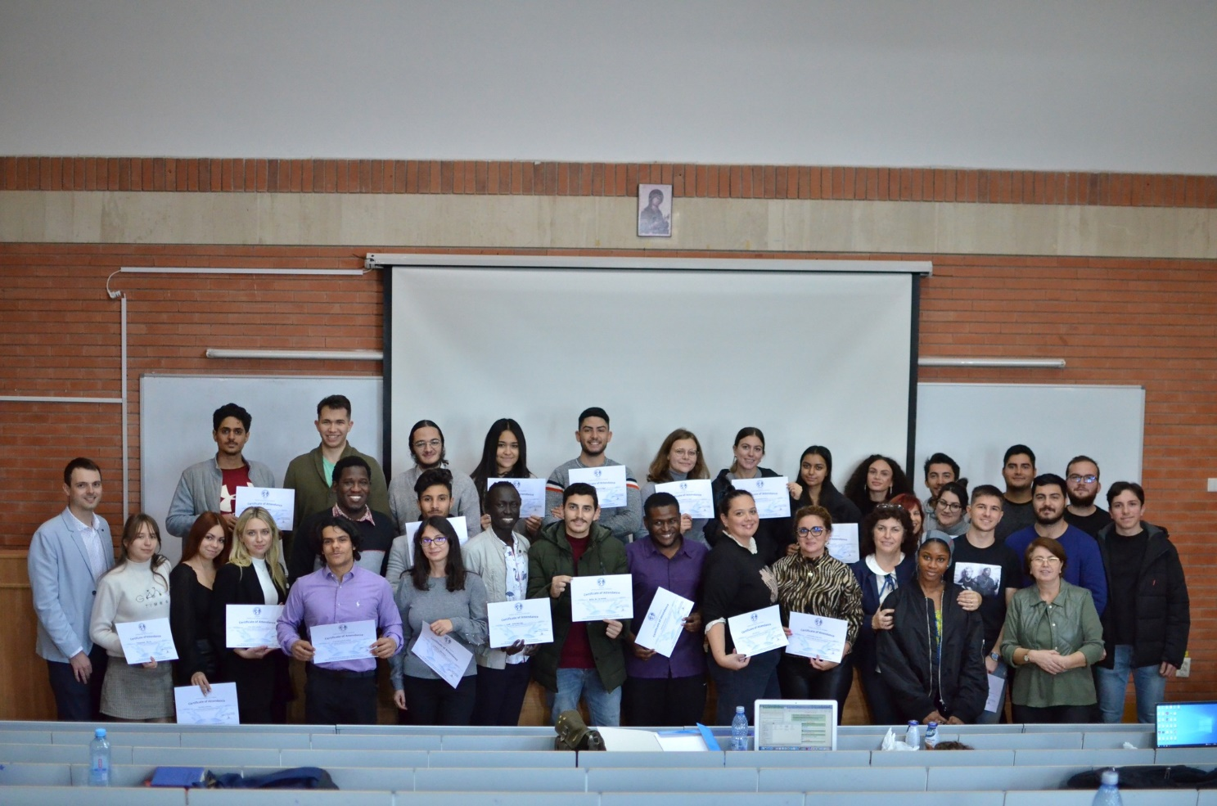

21-22 November 2025
Constanța, Romania

This event is supported by the NODENS PLUS project, code CNFIS-FDI-2025-F-0434,
financed by the Ministry of Education.

SCIENTIFIC COMMITTEE
• Professor Liliana Ana TUȚĂ, Ovidius University of Constanta
• Professor Cristina DUHNEA, Ovidius University of Constanta
• Associate Professor Cristina DAFINOIU, Ovidius University of Constanta
• Associate Professor Veronica NEDELCU, Ovidius University of Constanta
• Associate Professor Cristina GAFU, Petrol-Gas University Ploiești
• Associate Professor Laura PASCALE, Ovidius University of Constanta
• Associate Professor Magdalena PRUNEANU, University of Pitești
Associate Professor Daniela STOICA, Fan S. Noli University of Korce
• Associate Professor Alina IFTIME, Romanian Language Institute of Bucharest/Ankara University
• Lecturer Professor Cristina ROGOJINĂ, Ovidius University of Constanta
- Lecturer Professor Raluca LEVONIAN, Ovidius University of Constanța

ORGANIZING COMMITTEE
• Professor Liliana Ana TUȚĂ, Ovidius University of Constanta
• Professor Cristina DUHNEA, Ovidius University of Constanta
• Associate Professor Cristina DAFINOIU, Ovidius University of Constanta
• Associate Professor Veronica NEDELCU, Ovidius University of Constanta
• Associate Professor Laura PASCALE, Ovidius University of Constanta
• Lecturer Professor Cristina ROGOJINĂ, Ovidius University of Constanta
- Lecturer Professor Raluca LEVONIAN, Ovidius University of Constanța
- Professor Ludmila BRANIȘTE, Alexandru Ioan Cuza University of Iași
- Assistant Professor Ioana BRAȘOVEANU, Alexandru Ioan Cuza University of Iași
- Assistant Professor Arina CHIRILĂ, Alexandru Ioan Cuza University of Iași
• Călin Ioana Elena., Ovidius University of Constanta, Romania
• Andreea-Alina SOLTANIUC, Ovidius University of Constanta, Romania
• Mariana-Georgiana STAICU, Ovidius University of Constanta, Romania
• Bianca Emilia ANGHEL, Ovidius University of Constanta, Romania
• Cristina Elena SZENTE, Ovidius University of Constanta, Romania
FOREWORD
Welcome to the 5th edition of the International Conference “(Inter)cultural Dialogues”, organized by the Ovidius University of Constanta, Romania.
The conference aims to promote an international cultural environment within universities. The event aims to encourage dialogue and communication between participants to accelerate the internationalization of higher education institutions, turning them into places where everyone feels at home. Our hope is that such an event will give us the opportunity to get to know each other better and to share interesting information and opinions.
Contributors were encouraged to approach one of the main topics of the conference:
• Topic 1 - The country’s / region’s / city’s image - symbols / particularities / elements of uniqueness
• Topic 2 - Specific cultural elements: gastronomy, clothing, traditions, architectural styles
• Topic 3 - Local myths, stories, legends, fantastic characters
We would like to thank all participants for their efforts and contributions and to invite them to actively participate in conference events. We hope that you will have a valuable experience!

AGENDA
(Romania Time - UTC+2)

Day 1 date- 21.11.2025
09:00 - 09.30 | Registration
09.30 – 10.00 | Welcome speeches - Ovidius University of Constanta team  - Associate professor Lucia OPREANU, Phd.  Vice-Dean - Faculty of Letters  - Associate professor Veronica NEDELCU, Phd.  Department Director - Faculty of Letters  - Project Director prof. Cristina DUHNEA, PhD.  NODENS PLUS
10.00 - 10.30 | International Workshop
10.30 – 12.00 | Parallel sessions: Participants' presentations
12.00 - 13.00 | Lunch break
13.00 – 15.00 | Parallel sessions: Participants' presentations
15:00 | Award ceremony
Day 2 - 22.11.2025
09.00 - 19.00 | Social trip - Cultural Mosaic in Dobruja*  (Enisala Fortress; Tulcea city)  *During the trip, a meal will also be provided by the event organizers.

Conference venue:
Ovidius University of Constanta
1, University Alley, 900470 Constanţa, Romania
1st floor, Senate Hall

Contact: fdi2uoc@gmail.com
Organizing Committee

TIMETABLE FOR PRESENTATIONS
Presentations may not exceed 10 minutes.
Depending on the availability of participants, the timetable may be subject to change.

Section 1
Participants’ presentations (10:30 – 12:00)

Moderators:
Associate Professor Cristina Dafinoiu, Ovidius University of Constanta
Associate Professor Veronica Nedelcu, Ovidius University of Constanta
Associate Professor Laura Pascale, Ovidius University of Constanta

Venue: Campus A, 1st floor, room: Senate Hall
Link: https://ovidius.webex.com/meet/cristina.dafinoiu

No. | Participants
 | Boccali Emanuele, Bastia Umbra, Un Ponte Tra Passato, Presente E Futuro, coord. Raluca Levonian
 | Calate Serena, Napoli, La Citta Sulla Soglia: Tra Sacro E Profano, coord. Raluca Levonian
 | Elsa Xhindole, Legends And Folk Tales Of Pogradec As A Reflection Of National Cultural Identity, coord. Daniela Stoica
 | Joana Dudo, Megi Bregu, Tradition In Albania: A Deep Dive Into Identity, coord. Daniela Stoica
 | Elifsu Güner, Exploring Identity, Culture, And Symbolism in Turkish Carpet Art, coord. Alina Iftime

Section 2
Participants’ presentations (13:00 – 15:00)

Moderators:
Associate Professor Cristina Dafinoiu, Ovidius University of Constanta
Lecturer Cristina ROGOJINĂ, Ovidius University of Constanta

Venue: Campus A, 2nd floor, room 218
Link: https://ovidius.webex.com/meet/cristina.dafinoiu

No. | Participants
1 | Stela Georgieva, Alexandra Mihaylova, Steliqn Ivanov, Bulgarian Traditions, coord. Cristina Dafinoiu
2 | Khaled El Hasseny, Mauritania: History, Geography, And Prospects for Sustainable Development, coord. Cristina Rogojină
3 | Nuryyeva Shirin, Symbols And Traditional Clothing As Pillars Of Turkmen Cultural Identity, coord. Cristina Gafu
4 | Hajyyeva Aynur, Traditions and Joy: A Beginner’s Guide to Turkmen Weddings, coord. Cristina Rogojină
5 | Zafeirioy Aggelos, Haidari Andreas, Greece’s Anarcho-Synchronism, coord. Cristina Dafinoiu
6 | Muhammetnazarova Jemal, Cultural Identity Reflected In Turkmen Architectural Styles, coord. Cristina Gafu
7 | Anastasia Kozma, Myths That Shaped Ukrainian Heritage, coord. Ludmila Braniște
8 | Bisrat Birhanet Tsegay, A Cultural Tapestry. The Cultural Essence of Ethiopia, coord. Arina Chirilă

Section 3
Participants’ presentations (13:00 – 15:00)

Moderators:
Associate Professor Veronica Nedelcu, Ovidius University of Constanta
Associate Professor Laura Pascale, Ovidius University of Constanta
Lecturer Raluca Levonian, Ovidius University of Constanța

Venue: Campus A, 2nd floor, room 214
Link: https://meet.google.com/dcj-sezp-xbh

No. | Participants
 | Ahmedova Dilber, Ezizova Ayna, Turkmenistan, coord. Cristina Dafinoiu
 | Ahmed Boukhrouf, Meryem El Harty, Morocco – Cultural Heritage, Development and Tourism, coord. Veronica Nedelcu
 | Mercy Anyango Omondi, Raila Amolo Odinga. The Life And Story Of The Enigma Of Our Time, coord. Laura Pascale
 | Nikolova Ani, The Magic Of Bulgaria, coord. Laura Pascale
 | Jemuel Van Vliet, Belgium: A Multilayered Identity, coord. Magdalena Pruneanu
 | Nicholas Baicea Stoian, Cultural Elements Of New York City: A Mosaic Of Identities, coord. Magdalena Pruneanu
 | Motuzka Daria, Ukrainian Traditional Food, coord. Veronica Nedelcu
 | Megherbi Mohammed Yanis, Annaba: The Pearl of Eastern Algeria, coord. Ioana Brașoveanu

